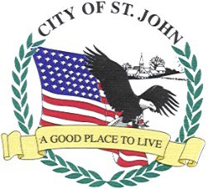
CITY OF ST. JOHN
8944 ST. CHARLES ROCK RD, SUITE 100 ST. JOHN, MO. 63114

VENDING MACHINE LICENSE APPLICATION

Vending Company’s Name: Date

Full Address: Phone

Applicant Name: ***APPLICANT’S SIGNATURE

Business Where Machine (s) are Located | Business Address | No Chance/ Gaming Machines  $500.00 | Machine Type | Machine Serial No. | Machine Fee  $15.00 | Cigarette Machine Fee  $25.00
Your Licenses will be returned by mail. It is your responsibility to see that they are distributed and properly affixed to the machines.
*** I hereby certify that the above application contains a true account of the vending machine(s) located at the listed location within St. John.

Pool halls are subject to additional regulations. See ordinance (Chapter 625 in City Code Book - https://ecode360.com/29085516)

