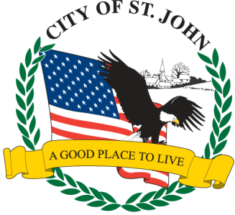
CITY OF ST. JOHN
8944 St. Charles Rock Road, St. John, MO 63114
314-427-8700 Fax: 314-427-6112 www.cityofstjohn.org

AFFIDAVIT OF GROSS SALES, AGGREGATE GOODS, & SERVICE FEES

On this day of , 2026, before me personally appeared:

Name of Applicant Title

Home Address City State Zip

Business Name Business Address

Who stated the sum of $ constituted the total gross sales/service fees/aggregate dollar amount of goods manufactured/service fees/etc. for the above named business for the year 2025 (Beginning Jan. 1st and ending Dec. 31st), and who further stated the sum of $ constitutes the total estimated gross sales/service fees/aggregate dollar amount of goods to be manufactured for the year 2026 (Beginning Jan. 1st and ending Dec. 31st).

Applicants Signature

Subscribed and sworn to before me this day of , 2026.

Notary Public
My Commission Expires:

