CITY OF ST. JOHN
8944 St. Charles Rock Road, St. John, MO 63114
314-427-8700 Fax: 314-427-6112 www.cityofstjohn.org

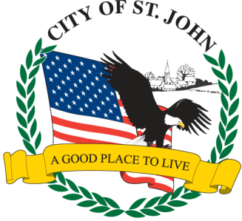
AFFIDAVIT OF GROSS SALES, AGGREGATE GOODS
AND SERVICE FEES

STATEMENT OF GROSS INCOME MUST BE ATTACHED VALIDATING NUMBERS LISTED ON “AFFIDAVIT OF GROSS SALES”

APPLICATION WILL BE REJECTED WITHOUT REQUIRED DOCUMENTATION

