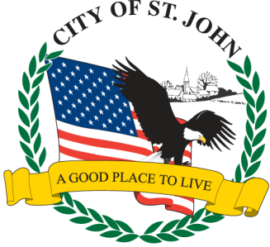
CITY OF ST. JOHN
8944 St. Charles Rock Road, St. John, MO 63114
314-427-8700 Fax: 314-427-6112 www.cityofstjohn.org

2026 EMERGENCY CONTACTS
It is mandatory that all business owners and/or managers submit at least three emergency contact persons who can be reached after normal business hours in the event of an emergency. The City of St. John Police Department needs to have on file the name, complete home address, and phone number(s) of each contact person so that someone can be reached in case of an emergency. If less than 3 separate persons names & information are submitted, the form is considered incomplete and will be returned to you for completion.

NOTE: IF OWNER AND/OR MANAGER WANTS TO BE CONTACTED, INCLUDE THEIR INFORMATION BELOW AS ONE AND/OR TWO OF THE CONTACTS.

NAME ADDRESS PHONE
1.

2.

3.

ST. JOHN BUSINESS NAME:
BUSINESS ADDRESS: ___________________________________________________

