CITY OF ST. JOHN
8944 St. Charles Rock Road, St. John, MO 63114
314-427-8700 Fax: 314-427-6112 www.cityofstjohn.org

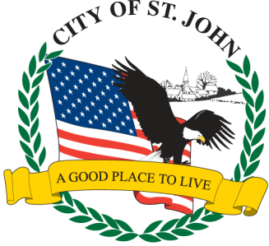
2026

CITY OF ST. JOHN, MISSOURI
APPLICATION FOR SEPARATE BUSINESS LICENSE

In addition to the regular business license, there are separate license fees required for certain businesses. If an item below applies to you, please check and submit the additional license fee. If this doesn’t apply to your business, please fill in your business name and the note “N/A” behind it (i.e. City of St. John – N/A)

BUSINESS NAME

Retail Sales of Tobacco Products . . . . . . . . . . . . . . . . . . . . . . . . . . . . .
$125.00 (Cigarettes not sold in Vending Machines)

Off-Site Bank ATM machines (per machine) . . . . . . . . . . . . . . . . . . $300.00

APPLICANT SIGNATURE

