CITY OF ST. JOHN
8944 St. Charles Rock Road, St. John, MO 63114
314-427-8700 Fax: 314-427-6112 www.cityofstjohn.org

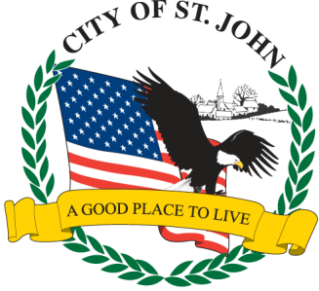
CERTIFICATE OF NO TAX DUE 2026

All business who collect sales tax must provide the “No Tax Due” letter from the State of Missouri with your application. Any letter submitted that is more than 90 days past the date of the letter, will not be acceptable and a new letter will have to be obtained

